7TH GRADE 2015-2016 VOCABULARY -STEM LEXICON
STEM | DEFINITION | EXAMPLE WORD
ABLE, IBLE | CAPABLE OF | flexible, portable
AL | RELATING TO | parental
ANCE | ACT OF, STATE OF | performance
BI | TWO | bicycle
EX | OUT OF | exit
FACT | DO, MAKE | manufacture
GEO | EARTH | geology
IC, ISH | CHARACTERISTIC OF | antagonistic
TRI | THREE | tricycle
IL, IR, IM ,IN, NON | NOT | illegible
PORT | CARRY | portable
OVER | ABOVE, EXCESSIVE | overextended
PRE | BEFORE | pretest
STRUCT | BUILD | construct
ANTI | AGAINST | antibullying
DORM | SLEEP | dormatory
CALOR | HEAT | caloric
CRED | BELIEVE | credible
CIDE | KILL | homocide
ASTRO | STAR | astrology
CORP | BODY | corpse
EPI | UPON, IN ADDITION | epicenter
FLEX | BEND | flexible
PERI | AROUND, ENCLOSING | perimeter
MACRO | LARGE | macrocosm
SEMI | HALF | semicircle
MAR, MARI | SEA, POOL | marine, marina
PSEUDO | FALSE | pseudonym
MONO | ONE | monochromatic
EU | WELL | eulogy
URE | ACT, PROCESS | procedure
SED | SIT | sedentary
LEG | READ | legible
ANIM | MIND | animated
TORT | TWIST | distort
NYM | NAME | homonym
SANCT | HOLY | sanctuary
META | CHANGE | metamorphosis
PETR | ROCK | petrify
MIR | WONDER | mirage
MAN | HAND | manicure
RECT | RIGHT | rectangle
VOLV | ROLL | revolve
DEMI | HALF | demigod
RETRO | BACKWARD | retroactive/retrospect
SENS | FEEL | sensation
FY | MAKE | solidify
OCUL | EYE | binocular
CUR | CARE FOR | curator
ULTRA | BEYOND | uLtraconservative
OID | APPEARANCE | android
GEST | CARRY | digest
APT | FIT | adapt
TACT | TOUCH | tactile
VOC | VOICE | vocal
RID | LAUGH | ridicule
PATH | FEELING | sympathy, empathy
A | NOT | apathy
NOMY | LAW | astronomy
FID | FAITH | fidelity
CACO | BAD | cacography
HETERO | DIFFERENT | heterogeneous
SCI | KNOW | science
GRAPH | WRITE | autograph
LAT | SIDE | unilateral
LITH | ROCK | lithograph
TRACT | PULL | tractor
IN | IN OR NOT | insane
CO | TOGETHER | coauthor
PHILE | LOVE | bibliophile
INE | NATURE OF | crystalline
-AR | RELATING TO | circular
HEXA | SIX | hexagon
FRACT | BREAK | fracture
PLATY | FLAT | plateau, platypus
THEO | GOD | theology
FIN | END | final
HEDRON | SIDED- OBJECT | polyhedron
AMBUL | WALK | ambulatory
OUS | FULL OF | glorious
TOPO | PLACE | topographical
PED | CHILD OR FOOT | pedicure
MORT | DEATH | mortuary
CARN | FLESH | carnivore
PSYCH | SOUL | psychology
ETHNO | RACE OR CULTURE | ethnic group
GEN | ORIGIN | genetics
NAT | BORN | prenatal, native
PALEO | OLD | paleolithic
CURS | RUN | cursive
CRYPT | HIDDEN | cryptic
CAD | FALL | cascade
CAPIT | HEAD | decapitate
LOQU | TALK | loquacious (someone who talks a lot)
SACRO | HOLY | sacred
UNI | ONE | unicycle
NESS | QUALITY | kindness
ALT | HIGH | altitude
ICS | art | graphics
ISO | EQUAL | isosceles
VERT | TURN | convert
ATE | CAUSE | dominate
COR | HEART | coronary
ESS | FEMALE | lioness
MUTA | CHANGE | mutation
FUG | FLEE | fugitive
-i | PLURAL | fungi, bacilli
JUS | LAW | justice
LUM | LIGHT | illuminate
ANN | YEAR | annual
APO | AWAY OR UP | apology
SEN | OLD | senior
SOL | ALONE | solitude
BAS | LOW | bass, basic
ROGAT | ASK | interrogation
PARL | SPEAK | parlor
POTENT | POWER | omnipotent
SURG | RISE | surge
LOG | WORD OR REASON | logic
GRAM | WRITING | telegram
CANT | SING | descant
REG | RULE | regulations
PRO | FORWARD | prospect
GYN | WOMAN | gynecology
AG | TO DO | agent
ACT | TO DO | action
MOB | MOVE | mobile
SESS | SIT | session
FIC | MAKE | fiction
NOUNCE | TELL | announce
ANDRO | MAN | androphobic
AN- | WITHOUT | anarchy
AB | AWAY | abnormal
MEL | SONG | melody
ADEN | GLAND | adenoid
AER | AIR | aerial
ALB | WHITE | albino
ASE | ENZYME | proteinase
EPI | ON | epicenter
HUM | EARTH | posthumous
-BE | LIFE | microbe
BON | GOOD | bonus
STRUCT | BUILD | construct
CHLOR | GREEN | chlorophyll
CYAN | BLUE | cyanosis
CYT | CELL | cytoplasm
DIPLO | DOUBLE | diplomacy
DYS | BAD | dysentery
ECO | HOUSE | ecosystem
EMIA | BLOOD | anemia
ENTER | INTESTINE | enteritis
ERYTHRO | RED | erythrocyte
IDIO | PECULIAR | idiot
EXO | OUT | exogenous
IM | NOT | impossible
FIL | THREAD | filament
CHROM | COLOR | monochrome
FORM | SHAPE | formative
SEQU | FOLLOW | sequence
GLYC | SWEET | glycose
HEMO | BLOOD | hemoglobin
ULTIMA | LAST | ultimate
INFRA | BENEATH | infra dig (beneath one)
LEUKO | WHITE | leukemia
LYS | BREAK DOWN | analysis
MESO | MIDDLE | mesophyll
MILLI | THOUSANDTH | millimeter
MEM | REMEMBER | memory
GRESS | STEP | digress
LABOR | WORK | collaborate
MYO | MUSCLE | myoglobin (a protein in muscle)
VAC | EMPTY | vacant
OLIGO | FEW OR SMALL | oligarchy
OSE | SUGAR | fructose
OSIS | CONDITION | psychosis
TUDE | STATE OF | solitude
PATHO | DISEASE | pathogenic  (capable of causing disease)
PHAG | EAT | phagocyte (cell that eats other cells)
PHOR | CARRY | euphoria
PHYT | PLANT | neophyte
PHYLL | LEAF | chlorophyll
PLEO | MORE | pleonasm (the use of more words than are necessary to convey meaning)
POD | FOOT | podiatrist
SOROR | SISTER | sorority
VAL | WORTH | equivalent
PARA | BESIDE, NEAR | paraphrase
DOM | RULE | dominate
ERG | WORK | synergy
RHIZ | ROOT | rhizoid (root like)
SAPRO | ROTTEN | saprophagous (feeding on dead or decaying animal matter)
SCHIZO | DIVIDE | schism (a division or or disunion, especially into mutually opposed parties)
HIPPO | HORSE | hippodrome ( an oval track for horse races)
SOM | BODY | somatic ( relating to the body)
SPOR | SEED | macrospore
STA | STOP | stationary
RHODO | ROSE | rhododendron
TAXIS | ARRANGEMENT | syntax (the arrangement of words to form sentences)
VOL | WILL | benevolent
FRAT | BROTHER | fraternity
TRICH | HAIR | trichosis ( disease or abnormal growth of hair)
TROPH | NOURISHMENT | autotroph (any organism capable of self- nourishment)
TOX | POISON | toxin
SECT | CUT | dissect
ZYGO | YOKE | zygote
ZYM | FERMENT | enzyme

- Abnormal  (Sadlier-Oxford Level B) | ADJ | Not usual, not typical, strange | Freakish, unnatural, irregular, anomalous | 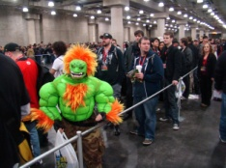
- Active Listener  (Academic Vocabulary) | N | Listener hears the message being sent, conveys understanding, and offers verbal/nonverbal feedback | NONE
- Agitation  (Sadlier-Oxford Lvl B) | N | A violent stirring or movement; noisy confusion, excitement, a stirring up of public enthusiasm | Disquiet, uneasiness, upset
- Analogy (CC)  (Academic Vocabulary) | N | Similarity between like features of two things on which a comparison may be based. | Comparison, correlation | __ is to ___ as ___ is to ____
- Anecdote  (Sadlier-Oxford Lvl B) | N | A short account o f an incident in someone’s life | Tale, story, sketch, vignette, yarn
- Antacid  (Word 2007 dictionary) | N | A drug that reduces or neutralizes stomach acid | NONE | 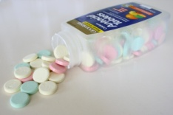
- Antagonistic  (Word 2007 dictionary) | ADJ | Showing or expressing hostility or opposition | Aggressive, hostile, opposed
- Argument (CC)  (Academic Vocabulary) | N | Discussion (oral or written) involving differing points of view; a process of reasoning | Oral disagreement, debate
- Astronomy  (Word 2007 dictionary) | N | The scientific study of the universe, especially of the motions, positions, sizes, composition, and behavior of astronomical objects. | NONE
- Barren  (Sadlier-Oxford Lvl B) | ADJ | Not productive, bare | Unproductive, sterile, desolate, arid | 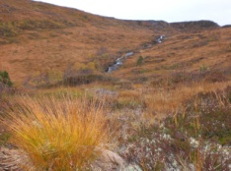
- Bewilder  (Sadlier-Oxford Lvl B) | V | To puzzle completely, confuse | Baffle, perplex
- Bias (CC)  (Academic Vocabulary) | N | Particular tendency or inclination, especially one that prevents unprejudiced consideration of a question | Prejudice, partiality, favoritism, influence
- Braggart  (Sadlier-Oxford Lvl B) | N/ADJ | (n) A boaster; (adj) boastful in a loud, annoying way | (n) bigmouth, blowhard  (adj) boastful
- Cache  (Sadlier-Oxford Lvl B) | N | A hiding place, something hidden or stored | Stockpile, hoard, store | 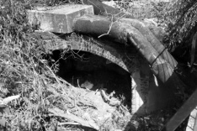
- Caloric  (Word 2007 dictionary) | N | Thermal: relating to or associated with heat | NONE
- Cite (CC)  (Academic Vocabulary) | V | To quote (a passage, book, author, etc.), especially as an authority; to mention in support, proof, or confirmation; refer to as an example | Quote, name
- Claim (CC)  (Academic Vocabulary) | N | Assertion of something as a fact | Assertion, declaration
- Clamor  (Word 2007 dictionary) | V/N | (v) To demand something noisily or desperately  (n) a persistent demand for something, made in an excited or angry way | (v) Shout, scream, yell (n) uproar, din, commotion. | 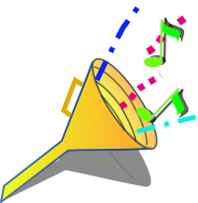
- Cohesion (CC)  (Academic Vocabulary) | N | Act or state of creating, uniting, or linking ideas to show relationships | Unity, consistency
- Coincide  (Sadlier-Oxford Lvl B) | V | To be in full agreement; to be the same in nature, character, or function,; to happen at the same time | Agree, concur, match
- Connotation (CC)  (Academic Vocabulary) | N | Attitudes and feelings associated with a word, associations can be negative or positive, and have an important influence on style and meaning | Nuance, undertone, suggestion
- Context (CC)  (Academic Vocabulary) | N | Parts of a written or spoken statement that precede or follow a specific word or passage, usually influencing its meaning or effect | Background, circumstance, situation
- Conventions (CC)  (Academic Vocabulary) | N | A term used to describe punctuation, spelling, and grammar* | NONE | 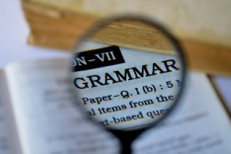
- Corporal  (Word 2007 dictionary) | ADJ/N | (adj) Relating to or affecting the body; (n) a noncommissioned officer in various armed forces, of a rank immediately below sergeant | (adj) Physical, bodily  (n)NONE
- Corporation  (Word 2007 dictionary) | N | A company recognized by law as a single body with its own powers and liabilities, separate from those of the individual members. | Business, company, firm
- Cosmopolitan  (Sadlier-Oxford Lvl B) | ADJ | Found in most parts of the world; having many fields of interest; of worldwide scope; sophisticated | Global, international, polished
- Countenance  (Sadlier-Oxford Lvl B) | N/V | (n) a face, facial expression; (v) to tolerate or approve | (n) expression  (v)support, condone | 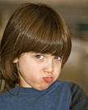
- Credibility (CC)  (Word 2007 dictionary)  (Academic Vocabulary) | N | The ability to inspire belief or trust; a willingness to accept something as true | Trustworthiness, reliability, integrity | 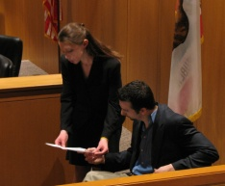
- Criticism (CC)  (Academic Vocabulary) | N | Act or art of analyzing and evaluating or judging the quality of a literary or artistic work, musical performance, art, exhibit, dramatic production, etc. | Analysis, appreciation
- Cynical  (Sadlier-Oxford Lvl B) | ADJ | Inclined to believe the worst in people; bitterly mocking or sneering | Skeptical, sarcastic contemptuous
- Denotation (CC)  (Academic Vocabulary) | N | Literal or dictionary definition of a word; contrasts with connotation | NONE | 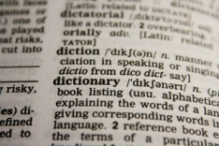
- Despondent  (Sadlier-Oxford Lvl B) | ADJ | Sad, without hope, discouraged | Dejected, depressed, forlorn
- Diminish  (Sadlier-Oxford Lvl B) | V | To make or become smaller, reduce in size | Lessen, decrease, dwindle
- Disputatious  (Sadlier-Oxford Lvl B) | ADJ | Inclined to argue or debate; provoking debate | Argumentative, quarrelsome, contentious
- Docile  (Sadlier-Oxford Lvl B) | ADJ | Easily taught, led, or managed; obedient | Manageable, teachable, pliant | 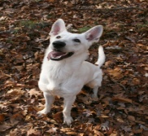
- Dormant  (Word 2007 dictionary) | ADJ | In an inactive state, when growth and development slow or cease, in order to survive adverse environmental conditions; temporarily inactive or not in use | Latent, inactive, sleeping, resting
- Dormitory  (Word 2007 dictionary) | N | A large room in which many people sleep, e.g. at a boarding school or in a hostel; a building used as living and sleeping quarters by college students | NONE
- Dupe  (Sadlier-Oxford Lvl B) | N/V | (n) a person easily tricked or deceived; (v) to deceive | (n)fool, scapegoat  (v) fool, hoodwink, mislead, delude | 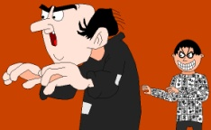
- Embezzle  (Sadlier-Oxford Lvl B) | V | To steal property entrusted to one’s care | Swindle, defraud
- Entice  (Sadlier-Oxford Lvl B) | V | To attract, tempt | Lure, beguile | 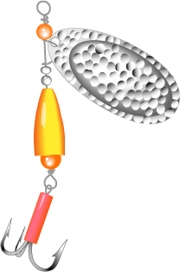
- Epicenter  (Word 2007 dictionary) | N | The exact location on the Earth's surface directly above the focus of an earthquake or underground nuclear explosion; the very center or focal point | Center, focal point | 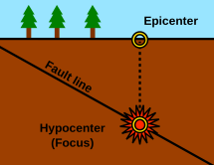
- Episode  (Word 2007 dictionary) | N | An event that is a part of but distinct from a greater whole and that often has specific significance | Incident, affair, event
- Eradicate  (Sadlier-Oxford Lvl B) | V | To root out, get rid of, destroy completely | Wipe out, uproot | 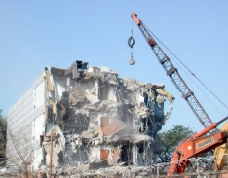
- Etymology (CC)  (Academic Vocabulary) | N | The history of a word; where it came from | NONE
- Eulogy  (Word 2007 dictionary) | N | Spoken or written tribute; high praise | Tribute, acclamation
- Eureka  (Word 2007 dictionary) | N | Expressing triumph | NONE
- Fact (CC)  (Academic Vocabulary) | N | Piece of information used as evidence or part of a report to prove that something truly exists or happens; fact vs. opinion; a belief, judgment, or way of thinking about something | Truth, reality, certainty
- Fallible  (Sadlier-Oxford Lvl B) | ADJ | Capable of being wrong, mistaken, or inaccurate | Imperfect, errant | 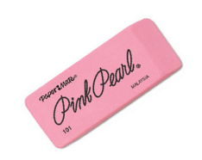
- Faulty Reasoning(CC)  (Academic Vocabulary) | N | (also known as faulty logic) Improper or mistakes in reasoning (Ex. Generalizations, bandwagon) | NONE
- Flagrant  (Sadlier-Oxford Lvl B) | ADJ | Extremely bad, flaring; scandalous, notorious | Blatant, gross, outrageous
- Fledgling  (Sadlier-Oxford Lvl B) | N/ADJ | (n) an inexperienced person, beginner; a young bird about to leave the nest; (adj) inexperienced, budding | (n) novice, tyro, neophyte; (adj) green, untried, raw | 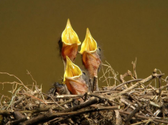
- Flexible  (Sadlier-Oxford Lvl B) | V | To change continually; to move up and down | Waver, seesaw, oscillate
- Fluctuate  (Word 2007 dictionary) | V | To change often from high to low levels or from one thing to another in an unpredictable way | Vary, change, alter | 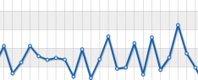
- Fratricide  (Word 2007 dictionary) | N | The act of killing one’s brother | NONE | 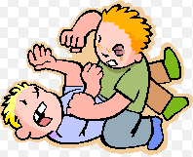
- Futile  (Sadlier-Oxford Lvl B) | ADJ | Not successful, failing to have any result; useless; unimportant, frivolous | Fruitless, vain, ineffective
- Haggle  (Sadlier-Oxford Lvl B) | V | To argue in a petty way, especially about a price | Bargain with, dicker with, wrangle | 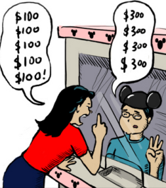
- Heartrending  (Sadlier-Oxford Lvl B) | ADJ | Causing mental pain or grief | Moving, sad, heartbreaking, poignant
- Hospitable  (Sadlier-Oxford Lvl B) | ADJ | Offering friendly or generous treatment to guests; open to anything new or strange | Gracious, cordial, courteous
- Implore  (Sadlier-Oxford Lvl B) | V | To beg earnestly for | Entreat, beseech, pray
- Incredulous  (Word 2007 dictionary) | ADJ | Unable or unwilling to believe something or completely unconvinced by it | Disbelieving, skeptical, doubtful
- Indignant  (Sadlier-Oxford Lvl B) | ADJ | Filled with resentment or anger over something unjust, unworthy, or mean | Offended, resentful, outraged, exasperated
- Indisposed  (Sadlier-Oxford Lvl B) | ADJ/PART | Slightly ill; disinclined to do something | Ailing, unwell, reluctant
- Inference  (Academic Vocabulary) | N | An idea the author does not directly state | Conclusion, reasoning, assumption
- Inflammable  (Sadlier-Oxford Lvl B) | ADJ | Easily set on fire; easily angered or aroused | Combustible, flammable, excitable
- Inflict  (Sadlier-Oxford Lvl B) | V | To give or cause something unpleasant, impose | Deal out, visit upon
- Informative (CC)  (Academic Vocabulary) | ADJ | Nonfiction writing in narrative or non-narrative form that is intended to inform | Explanatory, Expository
- Inimitable  (Sadlier-Oxford Lvl B) | ADJ | Not capable of being copied or imitated | Matchless, incomparable, unique
- Insinuate  (Sadlier-Oxford Lvl B) | V | To suggest or hint slyly; to edge into something indirectly | Imply, intimate
- Interpret (CC)  (Academic Vocabulary) | V | To construe or understand in a particular way | NONE
- Iota  (Sadlier-Oxford Lvl B) | N | A very small part or quantity | Speck, dab, jot, big, smidgen | 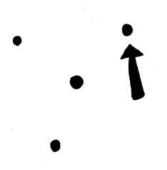
- Lavish  (Sadlier-Oxford Lvl B) | ADJ/V | Overly generous, extravagant; abundant; (v) to spend or give freely or without limit | (adj) excessive, profuse (v) pamper, shower | 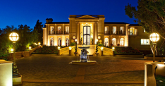
- Lecture  (Word 2007 dictionary) | N | An educational speech on a subject made before an audience; a lengthy reprimand or scolding concerning something | Talk, address, sermon, harangue
- Legitimate  (Sadlier-Oxford Lvl B) | ADJ | Lawful, rightful; reasonable, justifiable | Legal, right, proper, genuine | 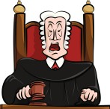
- Lethargic  (Sadlier-Oxford Lvl B) | ADJ | Unnaturally sleep; dull, slow moving, indifferent | Lazy, sluggish, listless
- Literary Elements (CC)  (Academic Vocabulary) | N | The parts of a story* | NONE
- Literary Device (CC)  (Academic Vocabulary) | N | Techniques used to highlight or place emphasis on parts of writing*
- Luster  (Word 2007 dictionary) | N | The quality of giving off light, brightness, glitter, brilliance | Gloss, sheen, shine | 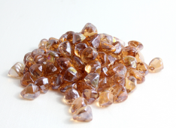
- Macrocosm  (Word 2007 dictionary) | N | A complex structure, e.g. the world or the universe, considered as a single entity that contains numerous similar smaller-scale structures | NONE
- Mar  (Sadlier-Oxford Lvl B) | V | To spoil, damage, injure | Scar, disfigure, deface | 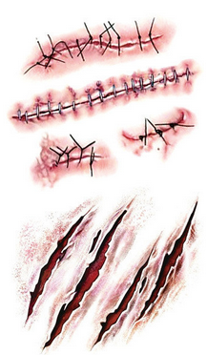
- Marginal  Sadlier-Oxford Lvl B) | ADJ | In, at, or near the edge or margin; only barely good, large, or important enough for the purpose | Borderline, minimal, peripheral | 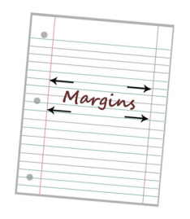
- Marine  (Word 2007 dictionary) | ADJ/N | (adj) Relating to, found in, or living in the sea; (n) military a soldier who serves at sea as well as in the air and on land | (adj) Maritime, nautical; | 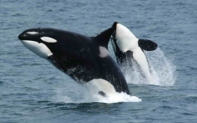
- Mariner  (Word 2007 dictionary) | N | A sailor or navigator of vessels at sea | NONE
- Melancholy  (Sadlier-Oxford Lvl B) | ADJ/N | (adj) sad, gloomy, unhappy; (n) dejection | (adj) depressed, dejected; (n) dejection
- Monomania  (Word 2007 dictionary) | N | An obsessive interest in a single thing, or a preoccupation with a single idea or thought | NONE
- Mononucleosis  (Word 2007 dictionary) | N | A significant rise in the number of atypical lymphocytes in the blood | NONE | 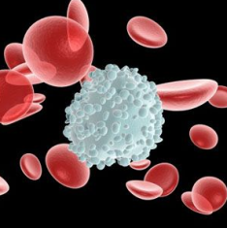
- Morbid  (Sadlier-Oxford Lvl B) | ADJ | In an unhealthy mental state, extremely gloomy; caused by or related to disease, unwholesome | Depressed, unsound, “sick”
- Narrative  (Academic Vocabulary) | N | The act or process of telling a story* | NONE | 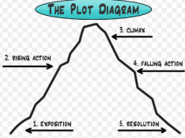
- Notorious  (Sadlier-Oxford Lvl B) | ADJ | Widely known because of bad conduct | Disgraceful, infamous, disreputable
- Officiate  (Sadlier-Oxford Lvl B) | V | To perform the duties of an office; to conduct a religious ceremony, to referee | Chair, preside, emcee, moderate | 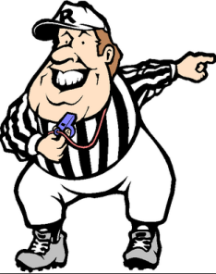
- Oppress  (Sadlier-Oxford Lvl B) | V | To govern, or rule cruelly or unjustly; to weigh heavily upon | Mistreat, persecute, grind underfoot
- Overture  (Sadlier-Oxford Lvl B) | N | An opening move toward negotiate or action; a proposal or offer; an introductory section or part | Prelude, tender | 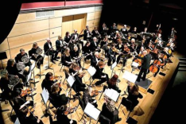
- Paradox  (Sadlier-Oxford Lvl B) | N | A self-contradictory statement that on closer examination proves true; a person or thing with seemingly contradictory qualities | Riddle, enigma, anomaly, absurdity
- Paraphrase  (Academic Vocabulary) | V | To express the meaning of something using different words | Reword, rephrase
- Peevish  (Sadlier-Oxford Lvl B) | ADJ | Cross, complaining, irritable; contrary | Crabby, cranky, testy, stubborn
- Periodic  (Word 2007 dictionary) | ADJ | Recurring or reappearing from time to time | Episodic, intermittent | 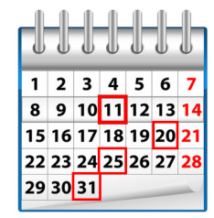
- Periscope  (Word 2007 dictionary) | N | A long tubular optical instrument, e.g. on a submarine, that uses lenses, prisms, and mirrors to allow a viewer to see objects not in a direct line of sight | NONE
- Pervade  (Sadlier-Oxford Lvl B) | V | To spread throughout | Saturate, permeate, diffuse, imbue | 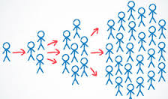
- Plagiarism (CC)  (Academic Vocabulary) | N | The unauthorized use of close imitation of the language and thoughts of another author and the representation of them as one’s own work | Copy
- Plot Structure (CC)  (Academic Vocabulary) | N | The basic elements in a plot line* | NONE | 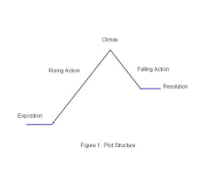
- Point of View(CC)  (Academic Vocabulary) | N | An opinion, attitude, or judgment | NONE | 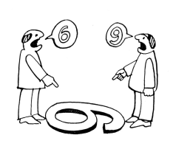
- Procure  (Sadlier-Oxford Lvl B) | V | To obtain through special effort; to bring about | Gain, acquire, achieve
- Prominent  (Sadlier-Oxford Lvl B) | ADJ | Standing out so as to be easily seen; important, well-known | Conspicuous, noticeable, important
- Pseudologue  (Word 2007 dictionary) | N | Pathological liar, making up conversation | NONE
- Pseudonym  (Word 2007 dictionary) | N | A name that is not somebody's original name, especially one used by an author in publications | Alias, nom de plume
- Puncture  (Word 2007 dictionary) | N/V | (n) A small hole or wound made by a sharp object;  (v) to sustain a small hole or wound in something such as a tire or the skin, or cause such a hole | (n) Perforation; (v) pierce, stab | 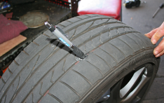
- Quench  (Sadlier-Oxford Lvl B) | V | To put out, extinguish, end | Douse, stifle, slake
- Ratify  (Sadlier-Oxford Lvl B) | V | To approve, give formal approval to, confirm | Endorse, sanction, uphold
- Recompense  (Sadlier-Oxford Lvl B) | V/N | (v) to pay back; to give a reward; (n) a payment for loss, service, or injury | Question, query
- Reflex  (Word 2007 dictionary) | ADJ/N | (adj) Occurring automatically and involuntarily; (n) an involuntary physiological reaction | (adj) NONE  (n) reaction, impulse | 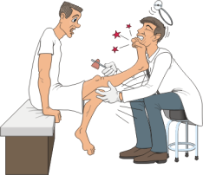
- Remnant  (Sadlier-Oxford Lvl B) | N | A small part remaining behind | Remainder, residue, leftover, fragment | 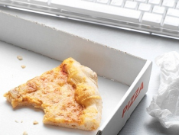
- Revere  (Sadlier-Oxford Lvl B) | V | To love and respect deeply, honor greatly | Admire, esteem, cherish
- Sagacious  (Sadlier-Oxford Lvl B) | ADJ | Shrewd; wise in a keen, practical way | Smart, clever, astute | 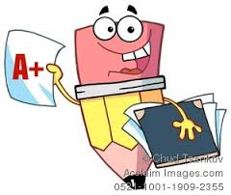
- Scald  (Word 2007 dictionary) | V/N | (v) to burn somebody or a part of the body with hot liquid or steam; (n) a burn caused by hot liquid or steam | (v) NONE; (n) burn, blister | 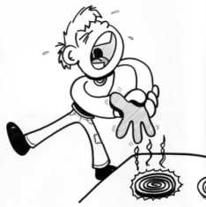
- Scrimp  (Sadlier-Oxford Lvl B) | V | To handle very economically or stingily; to supply in a way that is small, short, or scanty | economize
- Seethe  (Sadlier-Oxford Lvl B) | V | To boil or foam; to be excited or disturbed | Churn, simmer, stew | 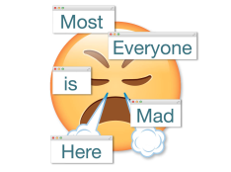
- Semicircle | N | Half of the area or circumference of a circle | Arc, half-moon | 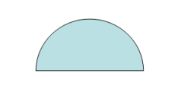
- Semimonthly  (Word 2007 dictionary) | ADJ | Happening or published twice each month, usually at equal intervals | NONE | 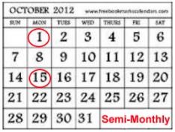
- Shirk  (Sadlier-Oxford Lvl B) | V | To avoid or get out of doing work, neglect a duty; to sneak, slink | Duck, sidestep
- Sodden  (Sadlier-Oxford Lvl B) | ADJ | Soaked with liquid or moisture; expressionless, dull, spiritless, listless | Drenched, waterlogged, saturated; languid, lethargic
- Stalemate  (Sadlier-Oxford Lvl B) | N/V | (n)A situation in which further action by either of two opponents is impossible; (v)to bring to a standstill | (n) standoff, draw  (v) to bring to a standstill | 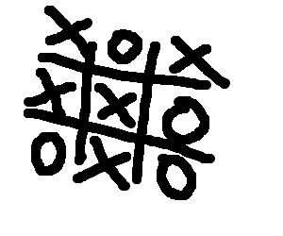
121. Stereotype  (Academic Vocabulary) | N | The oversimplification about a person or group; generalization | Typecast, label, pigeonhole | 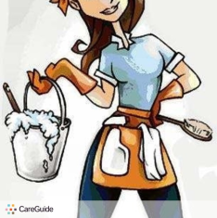
- Stodgy  (Sadlier-Oxford Lvl B) | ADJ | Dull, boring; old-fashioned, hidebound; lumpy, thick | Stuffy, tiresome, blah | 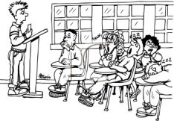
123. Suicide  (Word Dictionary 2007) | N | The act of deliberately killing yourself | None
- Synthesize  (Academic Vocabulary) | V | (BK + NK =SYN); to combine what one already knows with new information (diverse conceptions) to create an understanding; deductive reasoning | Manufacture, create, produce | 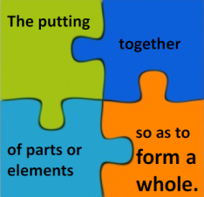
- Tension  (Academic Vocabulary) | N | The buildup of suspense or the conflict between characters | Pressure
- Text Evidence  (Academic Vocabulary) | N | Information from a passage used to prove or explain the reader’s thinking | NONE | 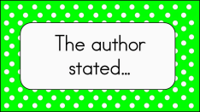
- Text Structure(CC)  (Academic Vocabulary) | N | The patterns and structures of text* | NONE | 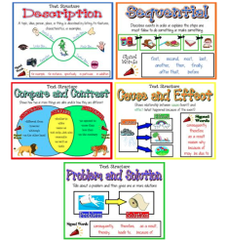
- Thesis Statement (CC)  (Academic Vocabulary) | N | An explanation of the topics or purpose of a research paper | NONE | 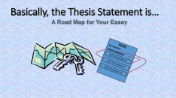
- Timidity  (Sadlier-Oxford Lvl B) | N | The state of being easily frightened | Fearfulness, faintheartedness
- Transition  (Academic Vocabulary) | N | A word or phrase in writing that smoothly connects one topic to the next | Shift, move | 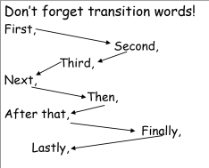
- Transparent | ADJ | Allowing light to pass through with little or no interruption or distortion so that objects on the other side can be clearly seen | See-through, clear, translucent | 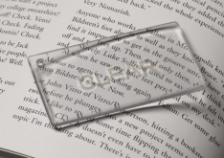
- Unscathed  (Sadlier-Oxford Lvl B) | ADJ | Wholly unharmed, not injured | Unhurt, sound, intact, unimpaired | 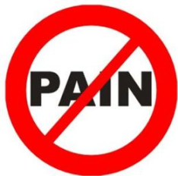
- Vanquish  (Sadlier-Oxford Lvl B) | V | To defeat in a battle or contest, overthrow; to overcome a feeling or condition | Beat, conquer, subdue
- Verify  (Sadlier-Oxford Lvl B) | V | To establish the truth or accuracy of, confirm | Prove, validate, substantiate
- Vigilant  (Sadlier-Oxford Lvl B) | ADJ | Wide-awake, alert, watchful | Attentive, on one’s toes
- Wayward  (Sadlier-Oxford Lvl B) | ADJ | Disobedient, willful; unpredictable, capricious | Perverse
- Wince  (Sadlier-Oxford Lvl B) | V/N | (v) to draw back suddenly, as though in pain or fear; (n) the act of drawing back in this way | (v) flinch, shudder, recoil; (n) flinch
- Works Cited  (Academic Vocabulary) | N | List of resources used for research | Bibliography | 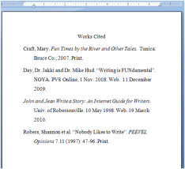
- Yearn  (Sadlier-Oxford Lvl B) | V | To have a strong and earnest desire | Crave, long for, want | 